Three-Point Perspective
# Source: AI Source: Provided by: [Data Path: Persons Table -> ID Column: 1, Name_En Column: Motasem Essam] -> From: [ChatGPT] on [7/25/2026]
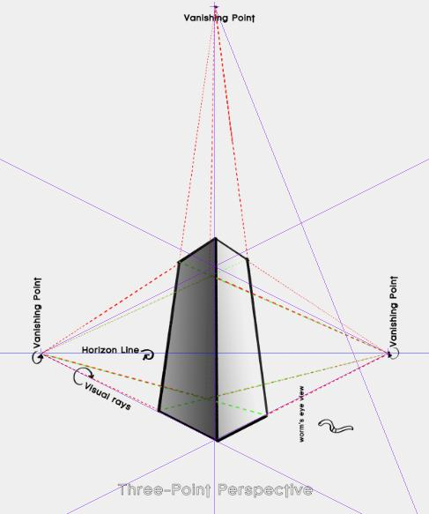
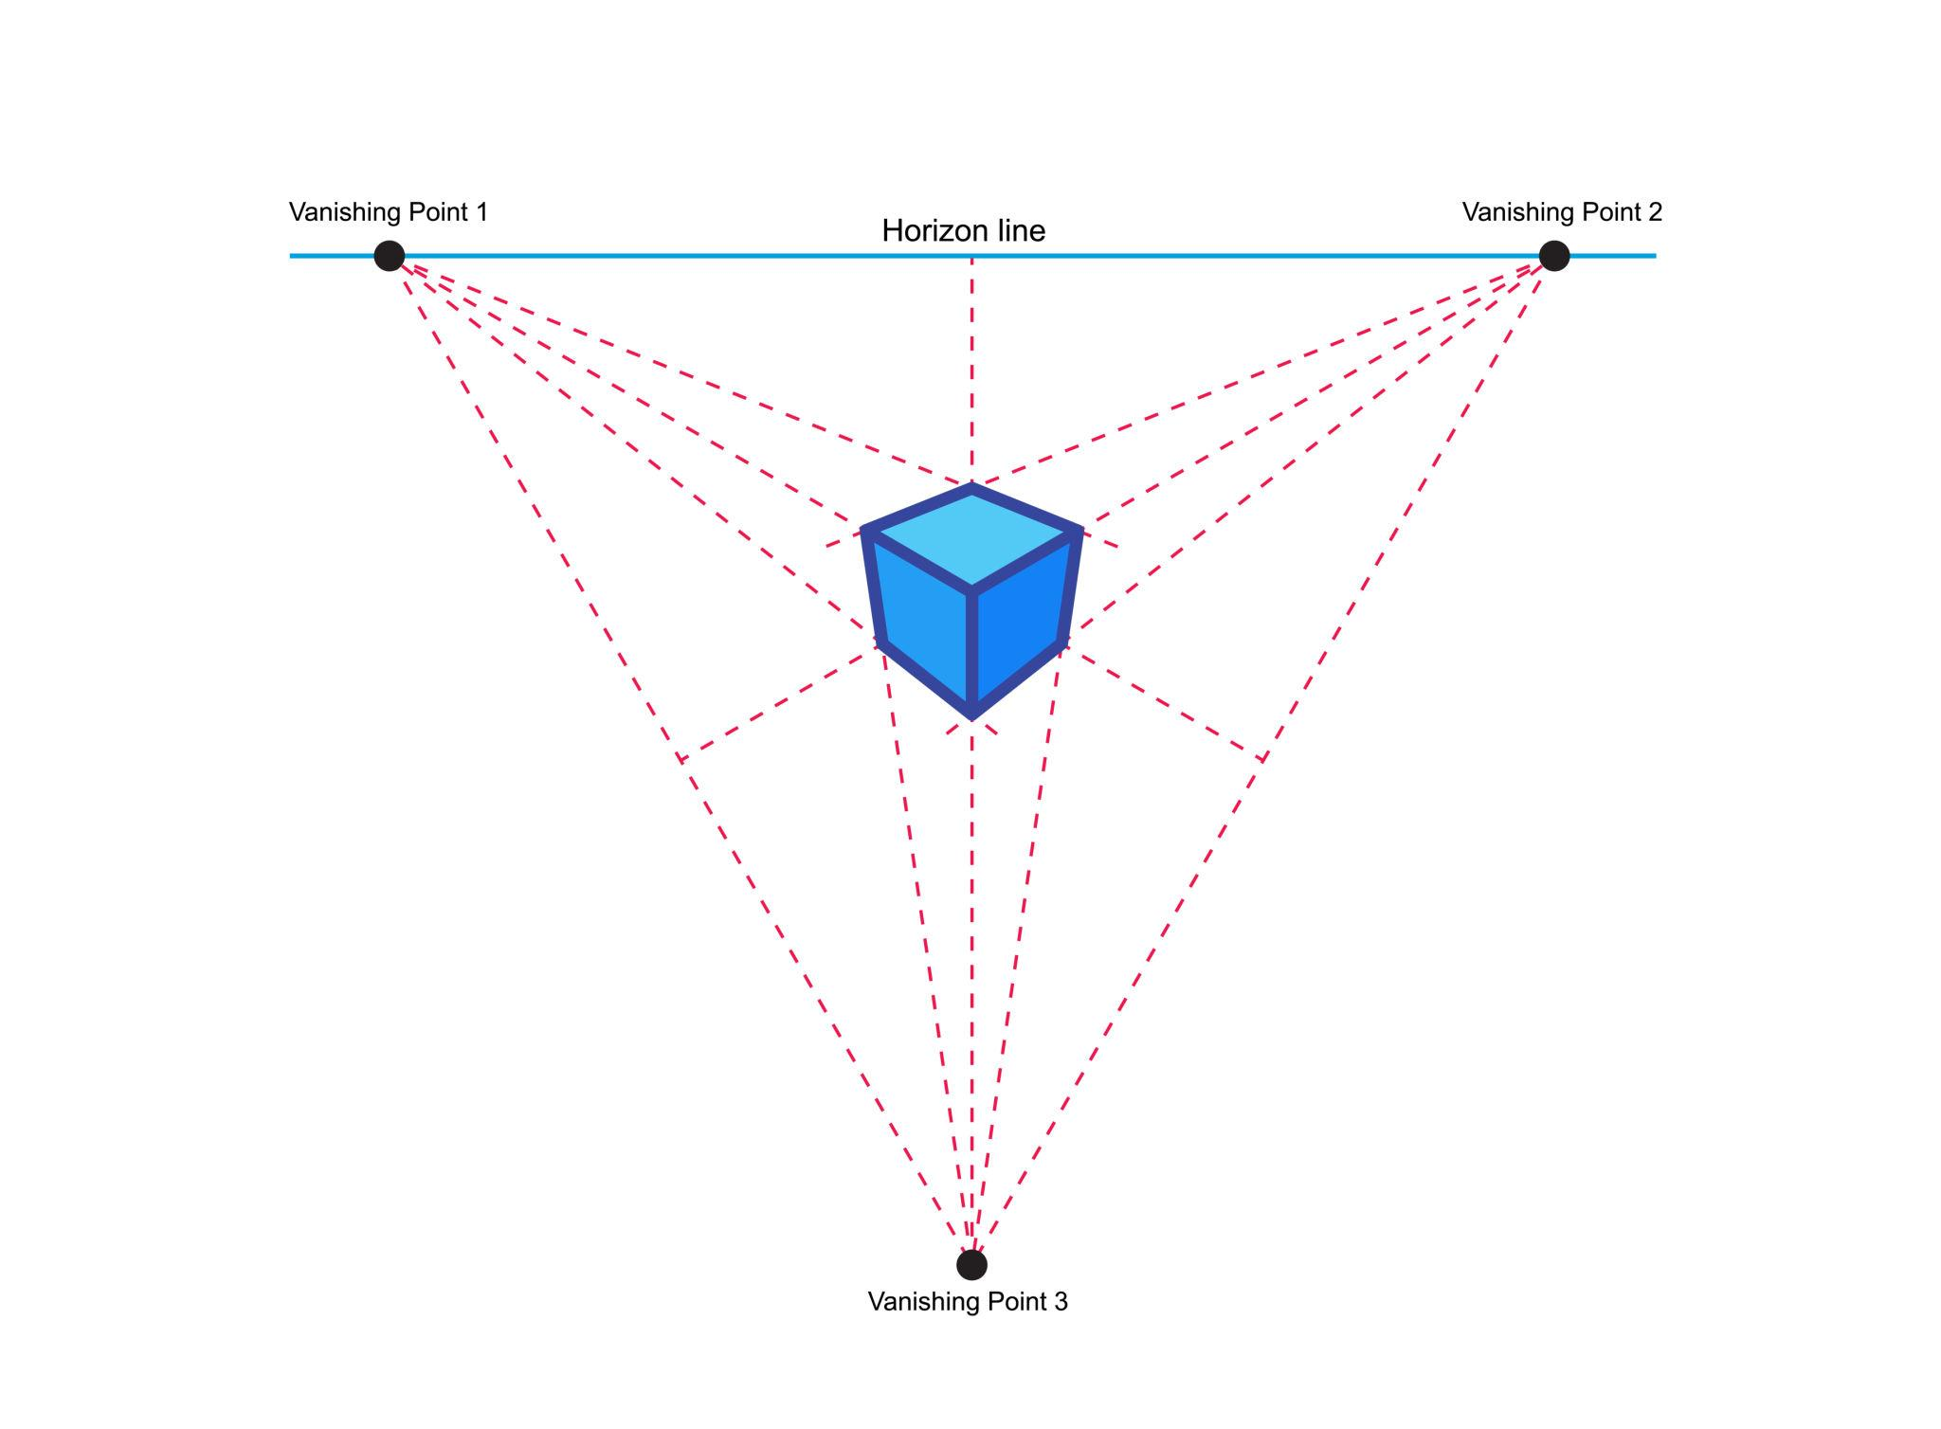
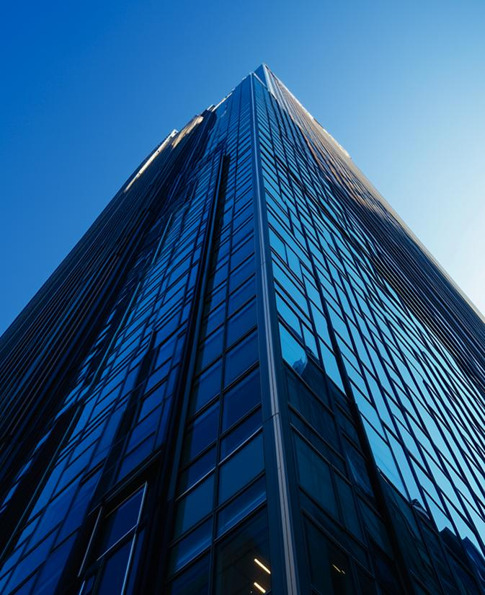
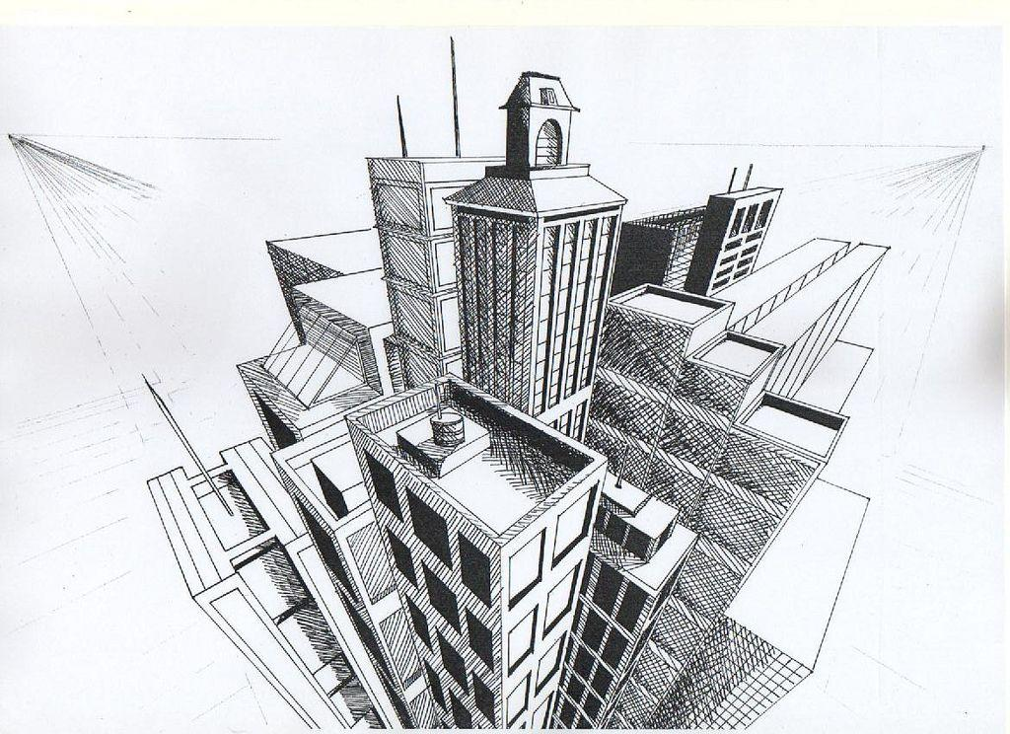
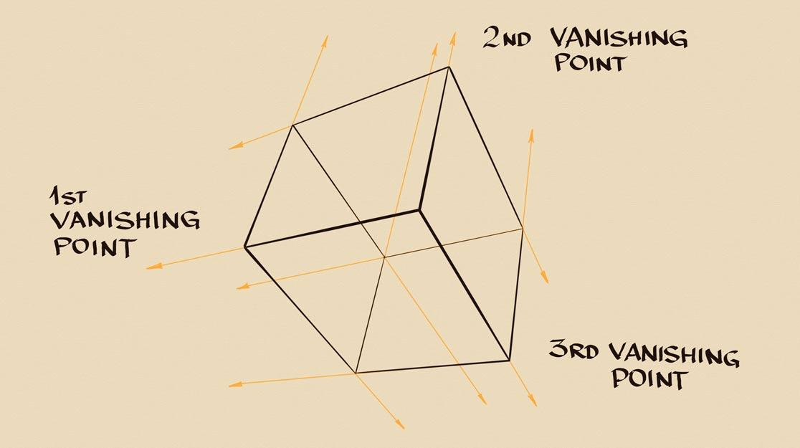
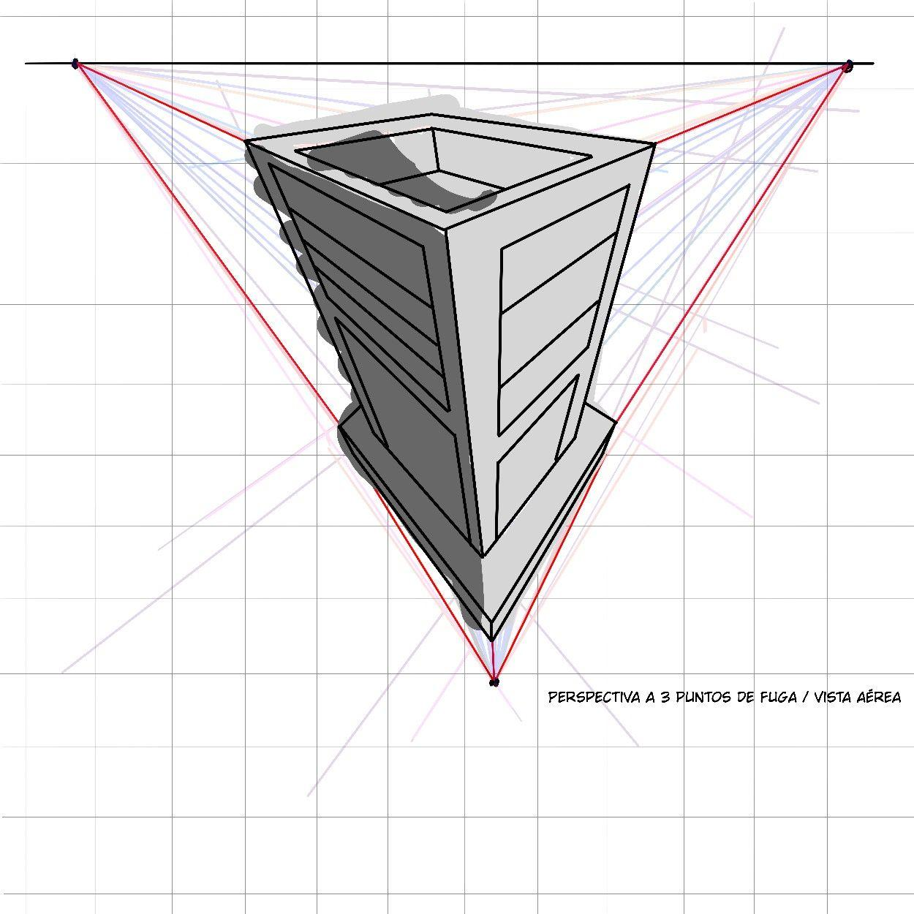
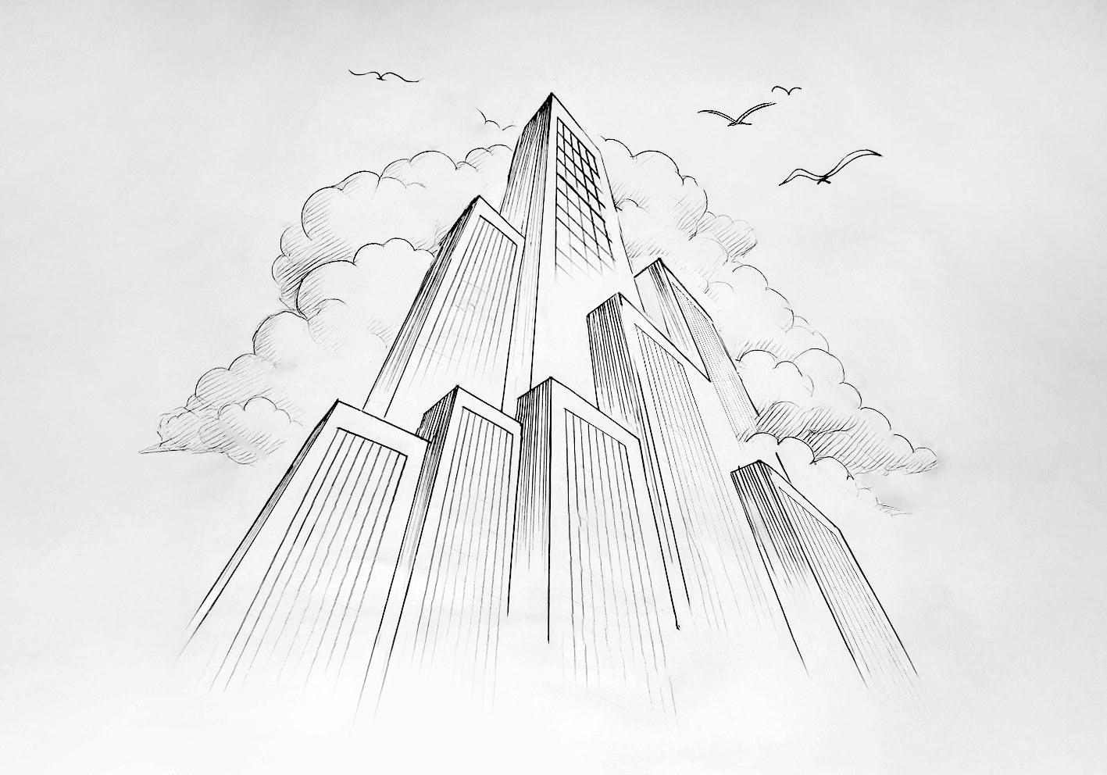

Definition
# Source: AI Source: Provided by: [Data Path: Persons Table -> ID Column: 1, Name_En Column: Motasem Essam] -> From: [ChatGPT] on [7/25/2026]
Three-Point Perspective is a type of perspective projection in which a three-dimensional object or scene is represented using three principal vanishing points.
It extends two-point perspective by allowing the vertical direction to converge toward a third vanishing point.
The three principal directions are therefore represented by three vanishing points:
$$\boxed{V_{L}, V_{R}, V_{V}}$$
where:
- $V_{L}$= left horizontal vanishing point
- $V_{R}$= right horizontal vanishing point
- $V_{V}$= vertical vanishing point
Thus:
$$\boxed{\text{Three-Point Perspective}=\text{Perspective Projection with Three Principal Vanishing Points}}$$
It is especially useful for viewing very tall or very deep objects from above or below.

Purpose
# Source: AI Source: Provided by: [Data Path: Persons Table -> ID Column: 1, Name_En Column: Motasem Essam] -> From: [ChatGPT] on [7/25/2026]
Three-point perspective is used to:
- Represent tall 3D objects realistically.
- Show buildings from above or below.
- Represent strong vertical depth.
- Create dramatic viewpoints.
- Represent skyscrapers and towers.
- Create realistic architectural perspectives.
- Produce cinematic scenes.
- Represent extreme camera angles.
- Create realistic computer graphics.

Basic Configuration
# Source: AI Source: Provided by: [Data Path: Persons Table -> ID Column: 1, Name_En Column: Motasem Essam] -> From: [ChatGPT] on [7/25/2026]
The three main vanishing points are:
$$V_{L}, V_{R}, V_{V}$$
The first two are horizontal vanishing points:
$$V_{L}, V_{R}$$
The third is the vertical vanishing point:
$$V_{V}$$
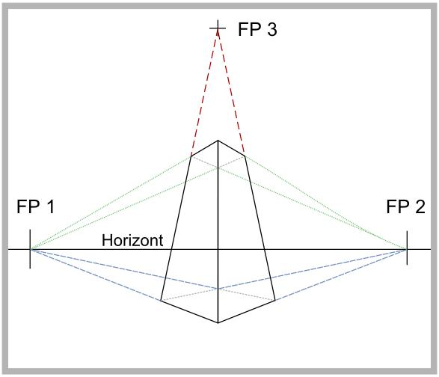
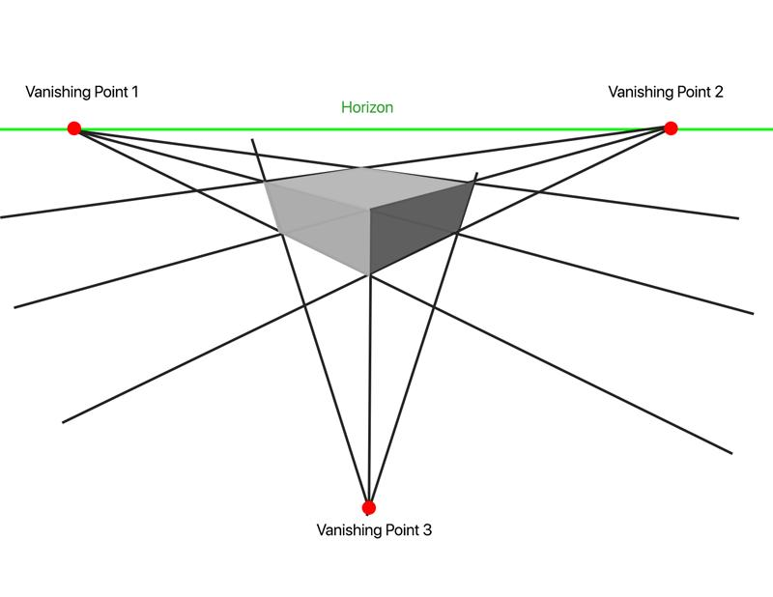
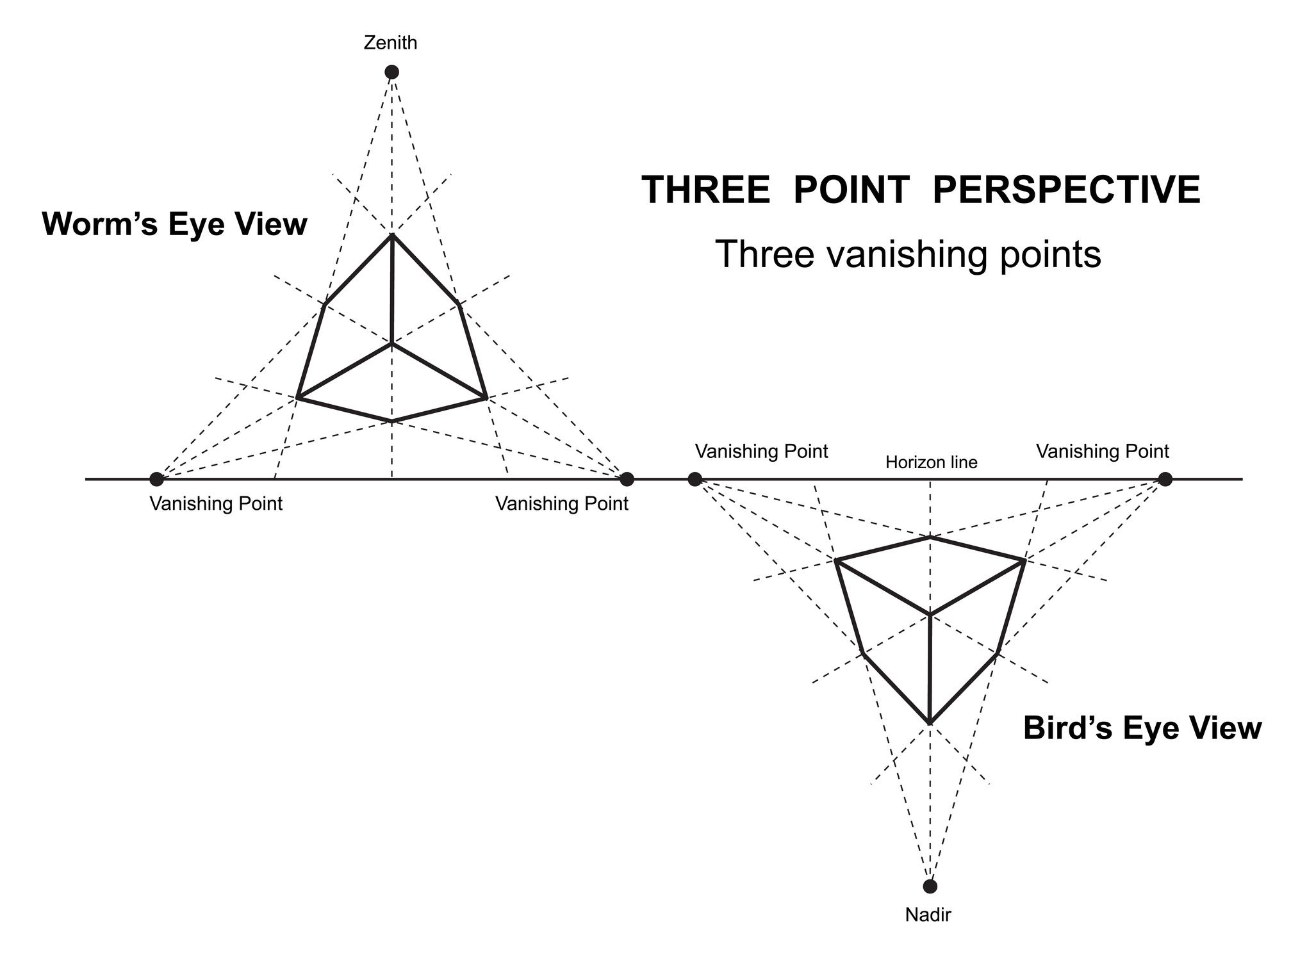
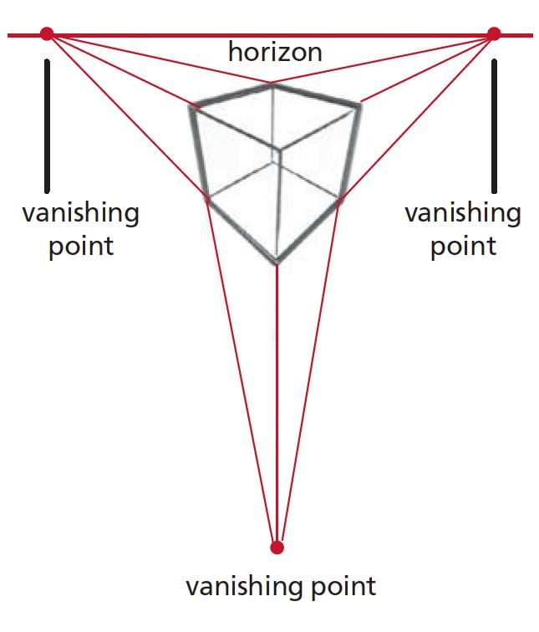
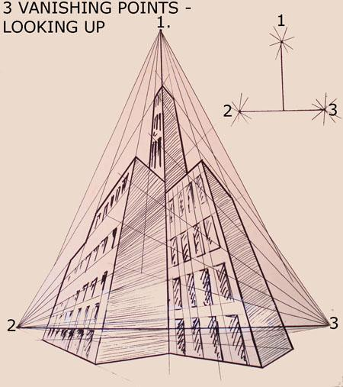
The two horizontal vanishing points lie on the horizon line:
$$\boxed{V_{L},V_{R}∈HL}$$
The vertical vanishing point is generally located above or below the horizon line, depending on the viewing direction.

Fundamental Elements

1. Projection Center
# Source: AI Source: Provided by: [Data Path: Persons Table -> ID Column: 1, Name_En Column: Motasem Essam] -> From: [ChatGPT] on [7/25/2026]
The viewpoint or center of projection:
$$O$$
All perspective projection rays originate from this point.

2. Projection Plane
# Source: AI Source: Provided by: [Data Path: Persons Table -> ID Column: 1, Name_En Column: Motasem Essam] -> From: [ChatGPT] on [7/25/2026]
The plane onto which the 3D scene is projected:
$$Π$$

3. Horizon Line
# Source: AI Source: Provided by: [Data Path: Persons Table -> ID Column: 1, Name_En Column: Motasem Essam] -> From: [ChatGPT] on [7/25/2026]
The horizon line represents the viewer's eye level:
$$HL$$
The two principal horizontal vanishing points lie on it:
$$V_{L},V_{R}∈HL$$

4. Left Vanishing Point
# Source: AI Source: Provided by: [Data Path: Persons Table -> ID Column: 1, Name_En Column: Motasem Essam] -> From: [ChatGPT] on [7/25/2026]
One horizontal direction converges toward:
$$V_{L}$$

5. Right Vanishing Point
# Source: AI Source: Provided by: [Data Path: Persons Table -> ID Column: 1, Name_En Column: Motasem Essam] -> From: [ChatGPT] on [7/25/2026]
The other horizontal direction converges toward:
$$V_{R}$$

6. Vertical Vanishing Point
# Source: AI Source: Provided by: [Data Path: Persons Table -> ID Column: 1, Name_En Column: Motasem Essam] -> From: [ChatGPT] on [7/25/2026]
The vertical direction converges toward:
$$V_{V}$$
This is the feature that distinguishes standard three-point perspective from standard two-point perspective.

Main Characteristics
# Source: AI Source: Provided by: [Data Path: Persons Table -> ID Column: 1, Name_En Column: Motasem Essam] -> From: [ChatGPT] on [7/25/2026]
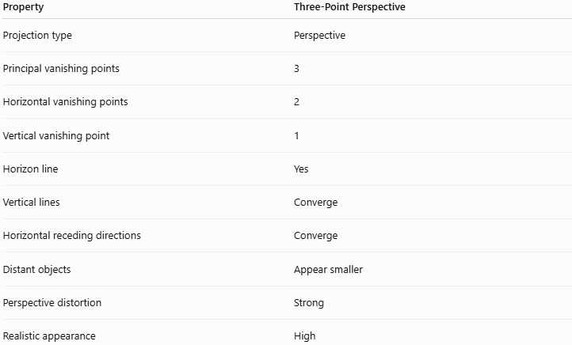
Property | Three-Point Perspective
Projection type | Perspective
Principal vanishing points | 3
Horizontal vanishing points | 2
Vertical vanishing point | 1
Horizon line | Yes
Vertical lines | Converge
Horizontal receding directions | Converge
Distant objects | Appear smaller
Perspective distortion | Strong
Realistic appearance | High

The Three Vanishing Points
# Source: AI Source: Provided by: [Data Path: Persons Table -> ID Column: 1, Name_En Column: Motasem Essam] -> From: [ChatGPT] on [7/25/2026]
Three-point perspective has three principal directions.
First direction
$$\boxed{\text{Direction 1}→V_{L}}$$
Second direction
$$\boxed{\text{Direction 2}→V_{R}}$$
Third direction
$$\boxed{\text{Vertical direction}→V_{V}}$$
Therefore:
$$\boxed{\text{Three principal directions}→\text{Three vanishing points}}$$
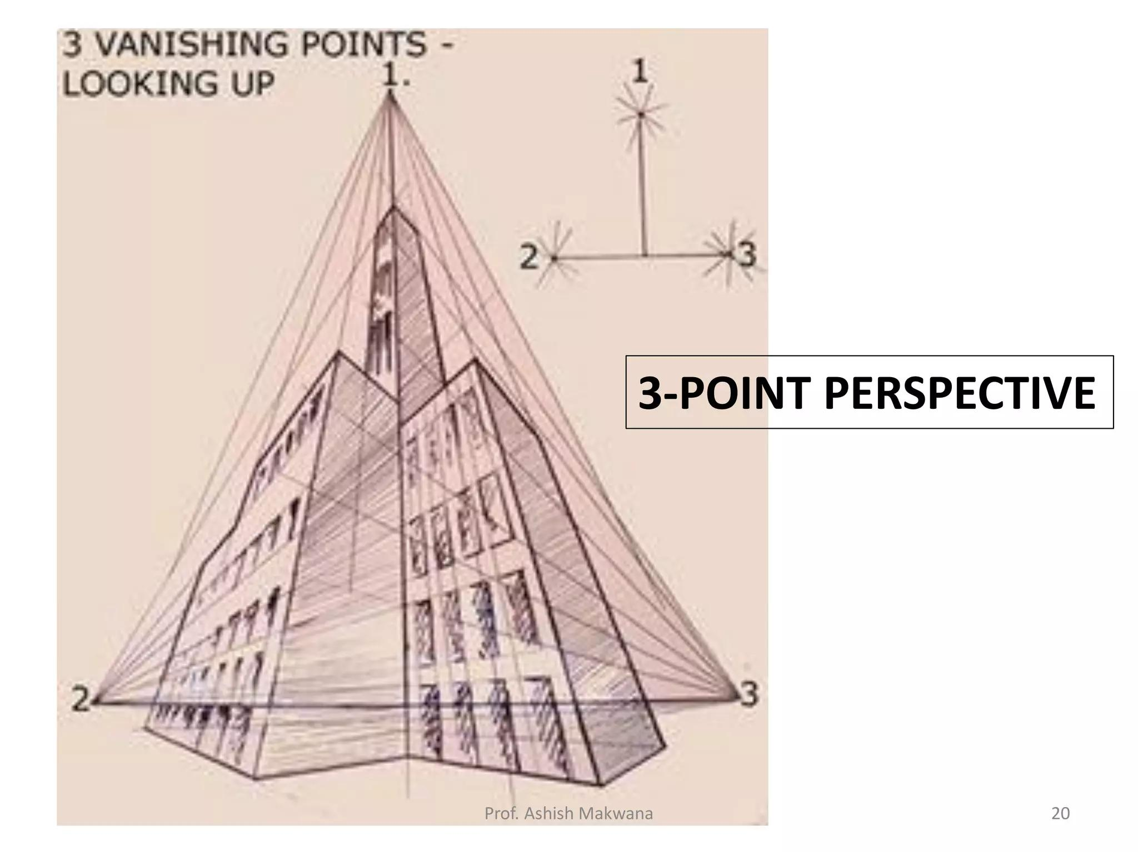
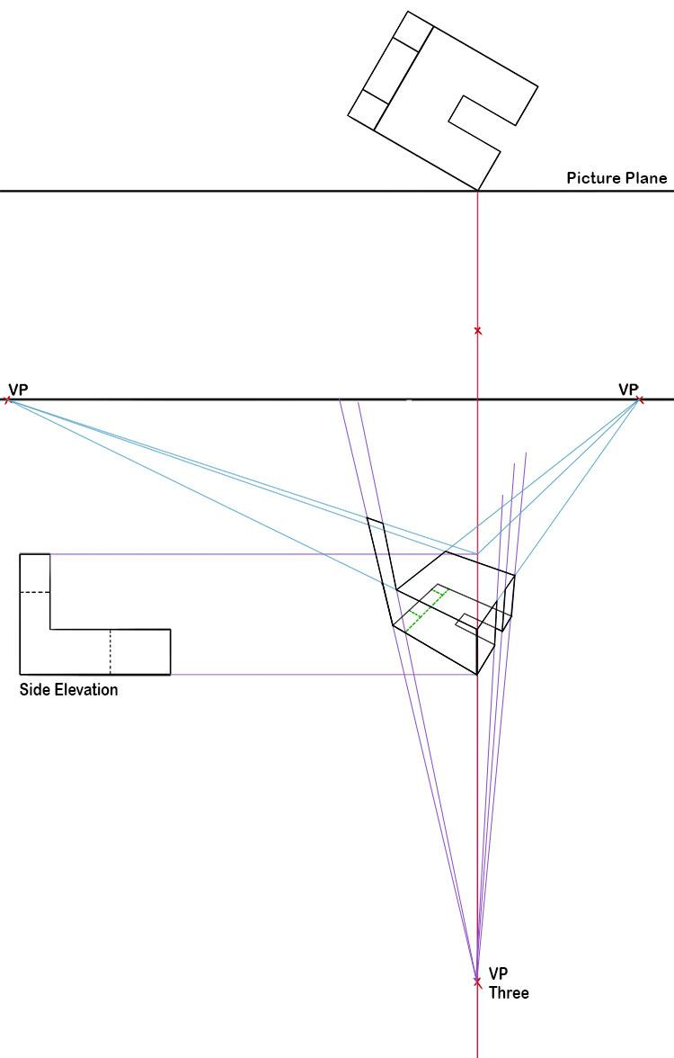

Three-Point Perspective of a Cube
# Source: AI Source: Provided by: [Data Path: Persons Table -> ID Column: 1, Name_En Column: Motasem Essam] -> From: [ChatGPT] on [7/25/2026]
Consider a cube viewed from a very low angle.
Instead of keeping its vertical edges parallel, the vertical edges converge toward a third vanishing point:
$$V_{V}$$
The two horizontal directions converge toward:
$$V_{L}$$
and:
$$V_{R}$$
Thus the cube has three principal vanishing directions.
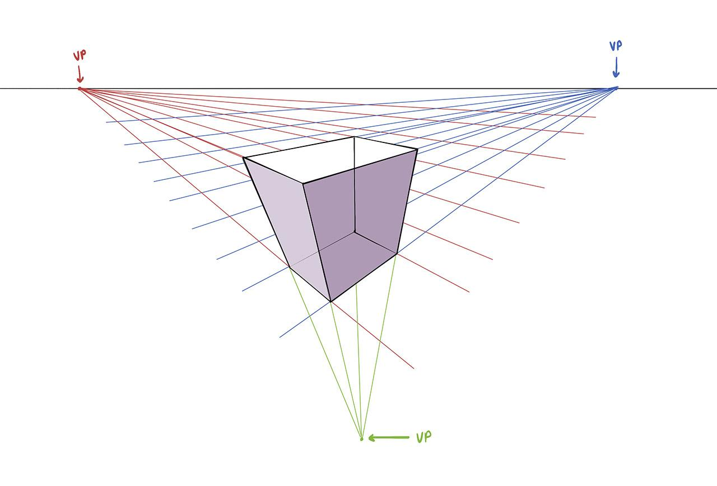
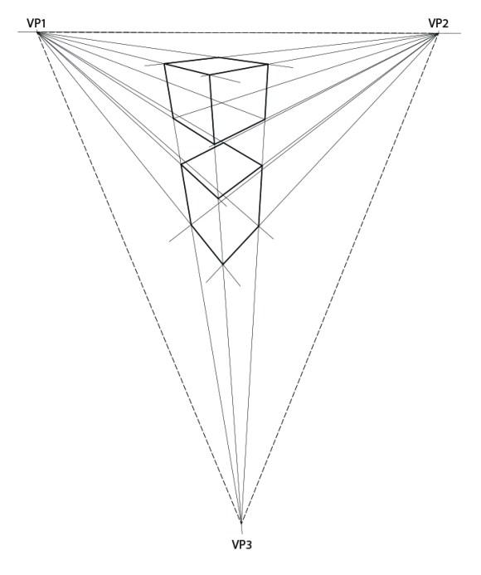
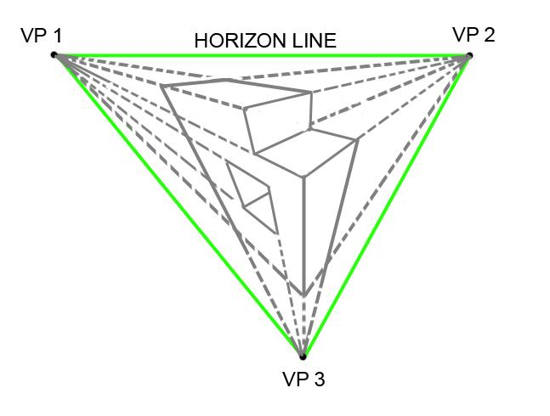

Three-Point Perspective of a Tall Building
# Source: AI Source: Provided by: [Data Path: Persons Table -> ID Column: 1, Name_En Column: Motasem Essam] -> From: [ChatGPT] on [7/25/2026]
A skyscraper is one of the clearest examples.
If you stand near the bottom and look upward:
- Left-facing horizontal edges converge toward $V_{L}$.
- Right-facing horizontal edges converge toward $V_{R}$.
- Vertical edges converge upward toward $V_{V}$.
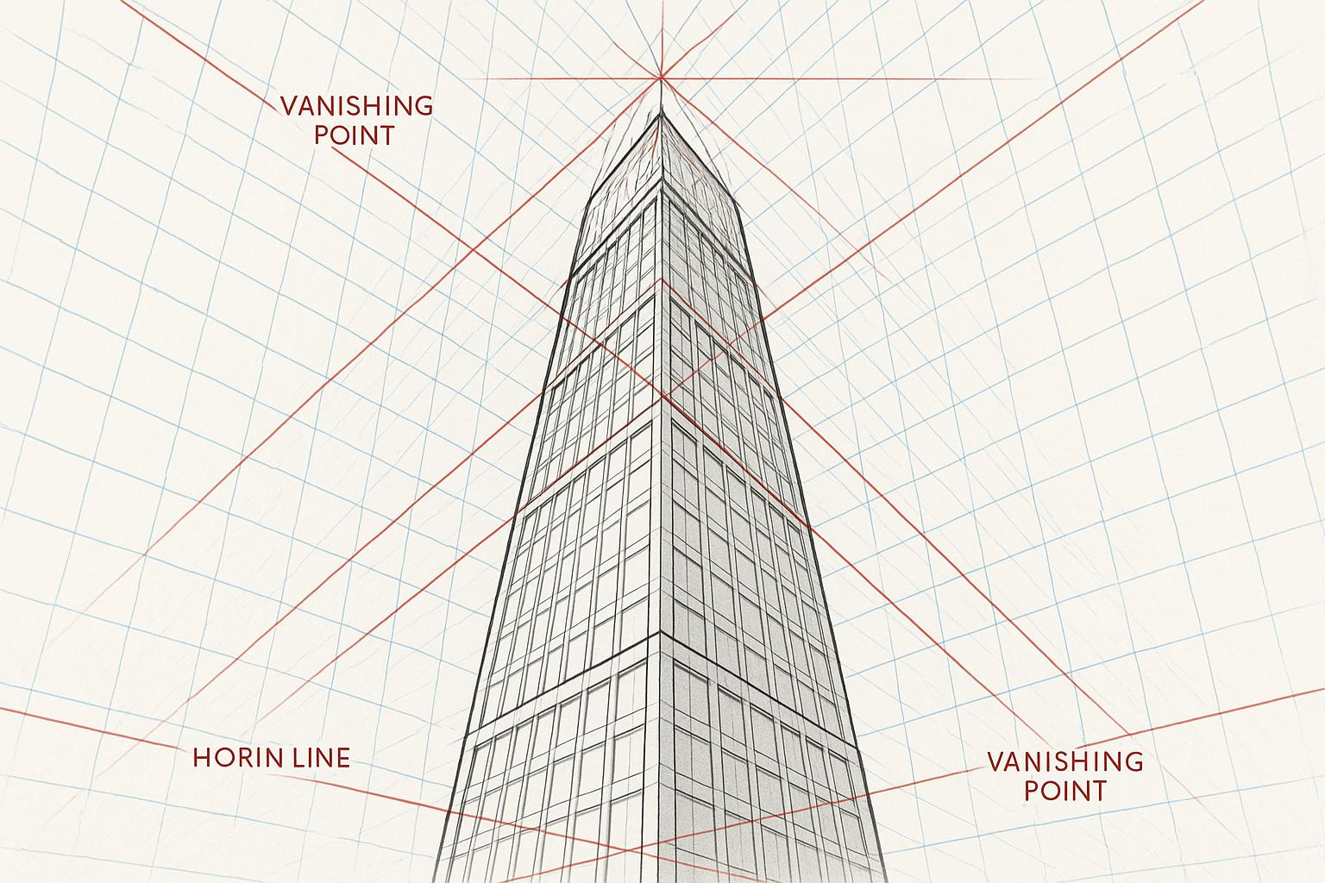

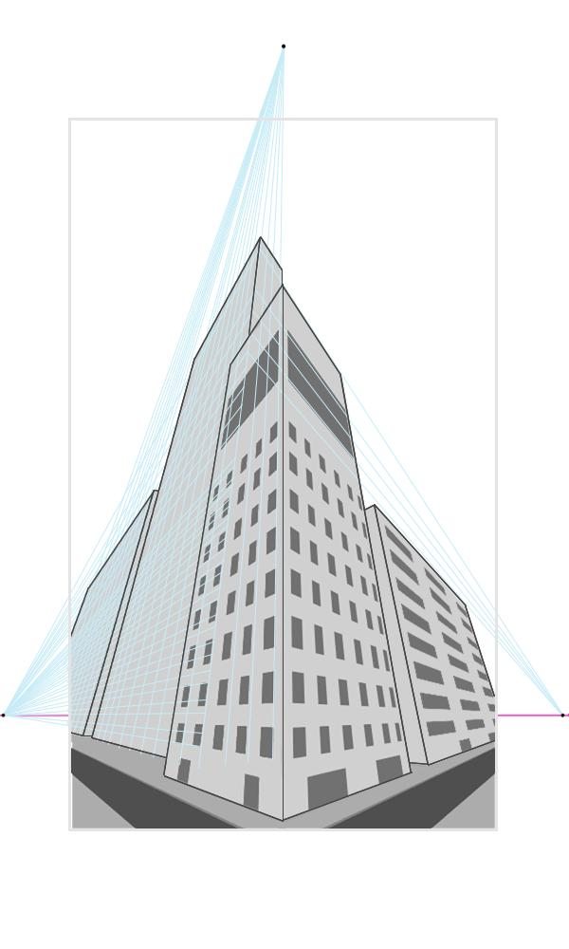
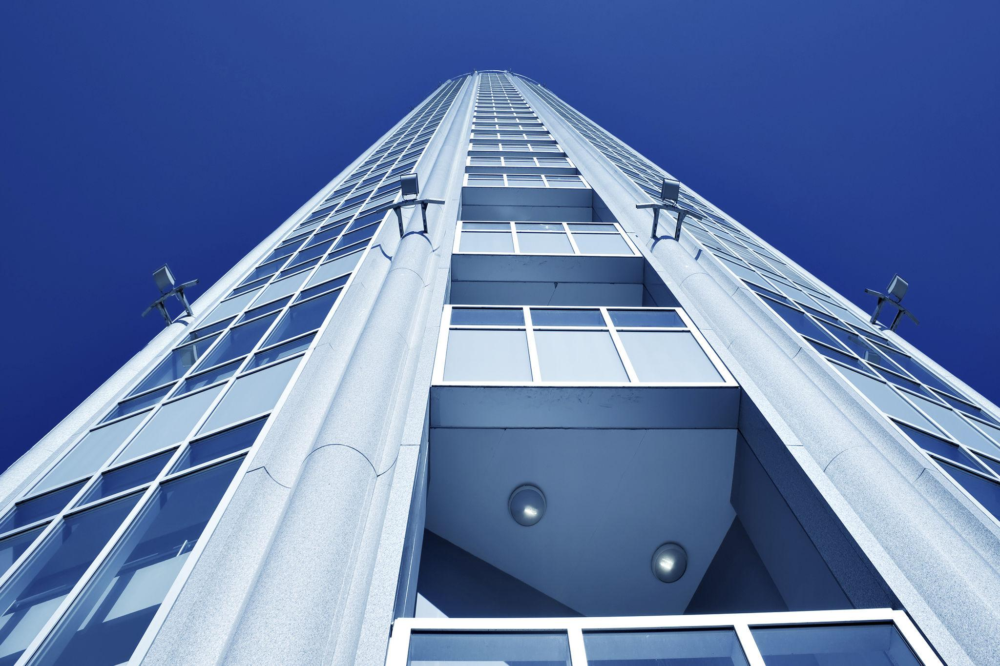
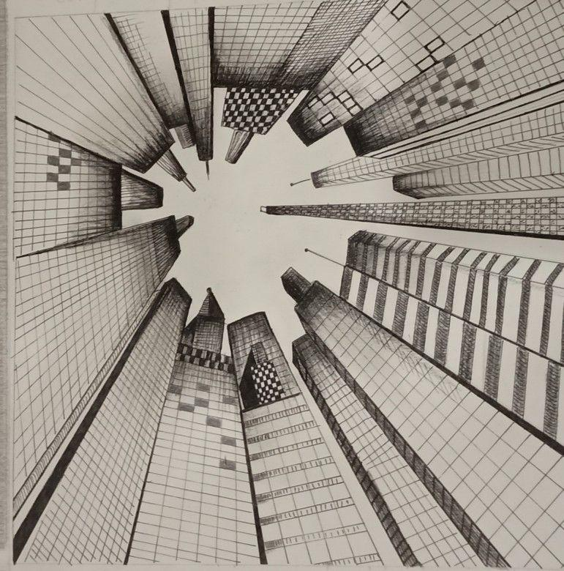
The third vanishing point produces the strong vertical convergence.

Looking Down
# Source: AI Source: Provided by: [Data Path: Persons Table -> ID Column: 1, Name_En Column: Motasem Essam] -> From: [ChatGPT] on [7/25/2026]
Three-point perspective can also occur when viewing an object from a high position and looking downward.
In this case, the vertical vanishing point is generally below the horizon line.
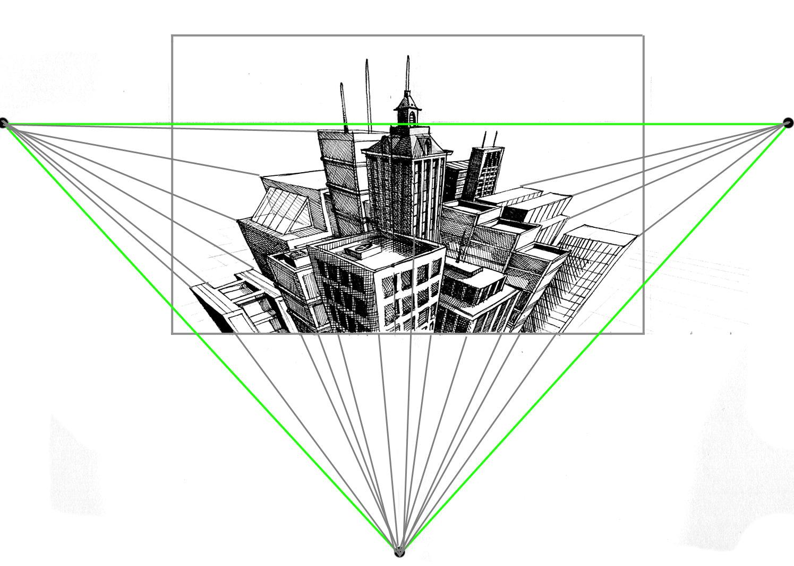
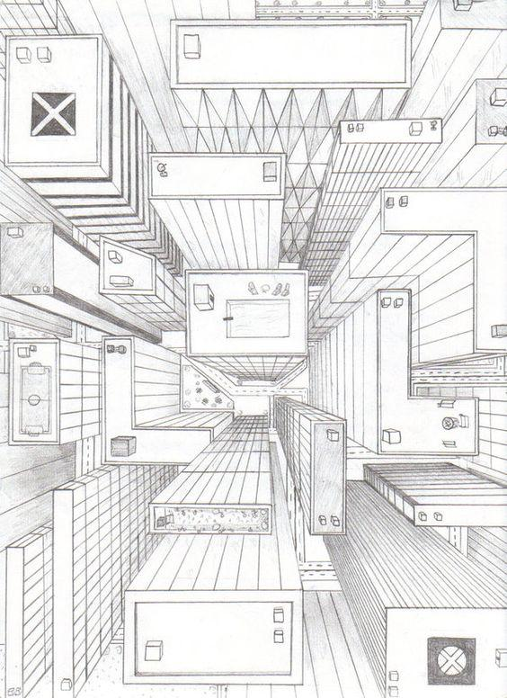
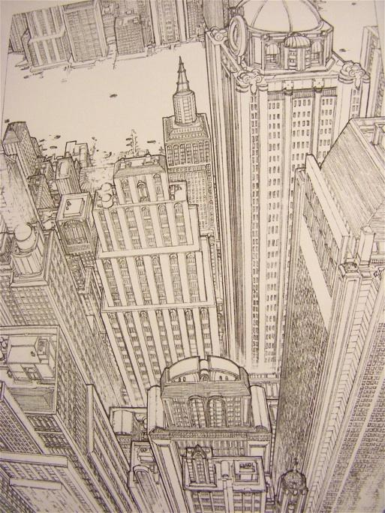
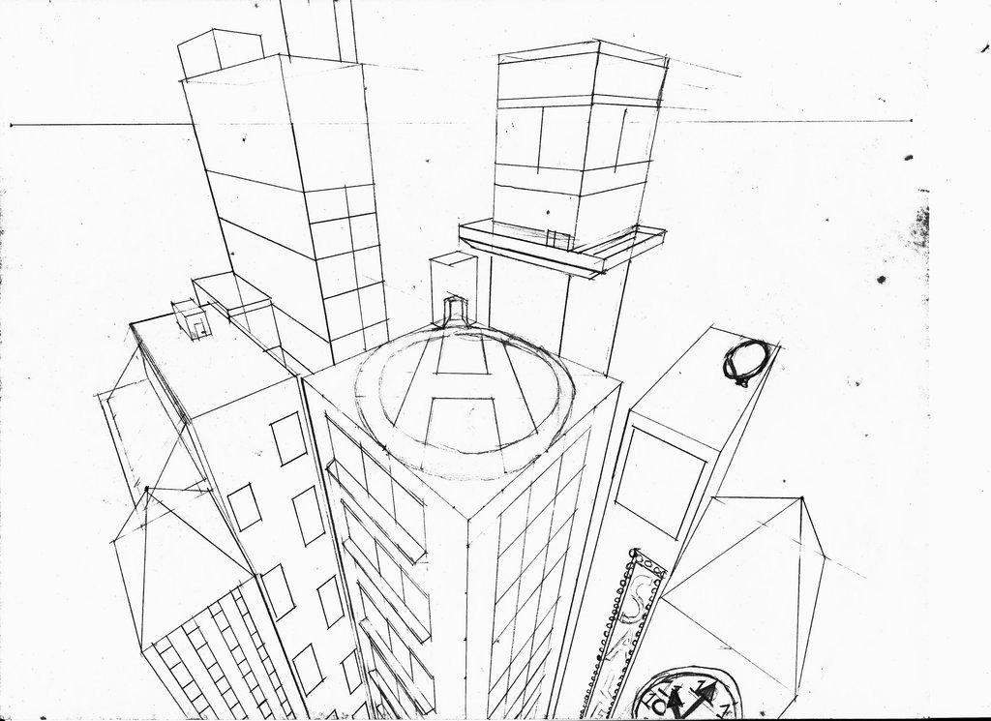
Therefore:
Looking upward
$$V_{V}\text{ is generally above }HL$$
Looking downward
$$V_{V}\text{ is generally below }HL$$

Mathematical Representation
# Source: AI Source: Provided by: [Data Path: Persons Table -> ID Column: 1, Name_En Column: Motasem Essam] -> From: [ChatGPT] on [7/25/2026]
Perspective projection can generally be represented by:
$$P^{'}=O+t\left(P-O\right)$$
where:
- $O$= projection center
- $P$= original 3D point
- $P^{'}$= projected point
- $t$= scalar determined by the projection plane
The three-point configuration occurs when the three principal spatial directions have three distinct vanishing points.

Vanishing Point of a Direction
# Source: AI Source: Provided by: [Data Path: Persons Table -> ID Column: 1, Name_En Column: Motasem Essam] -> From: [ChatGPT] on [7/25/2026]
Consider a family of parallel 3D lines with direction vector:
$$d$$
Under perspective projection, their images converge toward a common vanishing point associated with that direction.
Thus:
$$\boxed{\text{Parallel 3D lines with the same direction}→\text{one vanishing point}}$$
For three-point perspective, three principal directions produce:
$$d_{1}→V_{L} \\ d_{2}→V_{R} \\ d_{3}→V_{V}$$

Example 1: Skyscraper Viewed from Below
# Source: AI Source: Provided by: [Data Path: Persons Table -> ID Column: 1, Name_En Column: Motasem Essam] -> From: [ChatGPT] on [7/25/2026]
Suppose you stand near the base of a skyscraper and look upward.
The vertical edges extend away from you and appear to converge toward a point high above.
Therefore:
$$\boxed{\text{Vertical edges}→V_{V}}$$
The two horizontal directions converge toward:
$$V_{L}$$
and:
$$V_{R}$$
This produces the characteristic dramatic appearance of a tall building.

Example 2: Building Viewed from Above
# Source: AI Source: Provided by: [Data Path: Persons Table -> ID Column: 1, Name_En Column: Motasem Essam] -> From: [ChatGPT] on [7/25/2026]
Suppose you view a tall building from a high position.
The vertical edges now appear to converge downward:
$$\boxed{\text{Vertical edges}→V_{V}}$$
with:
$$V_{V}<HL$$
in the image coordinate arrangement where "below" means a lower image position.

Example 3: Cube
# Source: AI Source: Provided by: [Data Path: Persons Table -> ID Column: 1, Name_En Column: Motasem Essam] -> From: [ChatGPT] on [7/25/2026]
Suppose a cube is viewed from a low and angled position.
Its three principal edge directions can converge toward:
$$V_{L}, V_{R}, V_{V}$$
Thus:
$$\boxed{\text{3D cube}→3\text{ vanishing points}}$$

Horizon Line
# Source: AI Source: Provided by: [Data Path: Persons Table -> ID Column: 1, Name_En Column: Motasem Essam] -> From: [ChatGPT] on [7/25/2026]
The horizon line represents the viewer's eye level:
$$HL$$
The two horizontal vanishing points lie on it:
$$\boxed{V_{L},V_{R}∈HL}$$
The third vanishing point is generally not on the horizon line.
Instead:
$$\boxed{V_{V}∉HL}$$
in the usual three-point perspective configuration.

How to Construct Three-Point Perspective
# Source: AI Source: Provided by: [Data Path: Persons Table -> ID Column: 1, Name_En Column: Motasem Essam] -> From: [ChatGPT] on [7/25/2026]
Step 1 — Draw the Horizon Line
Draw:
$$HL$$
representing eye level.
Step 2 — Choose Two Horizontal Vanishing Points
Place:
$$V_{L}$$
and:
$$V_{R}$$
on the horizon line.
Step 3 — Choose the Vertical Vanishing Point
Place:
$$V_{V}$$
above or below the horizon line.
Step 4 — Draw the Nearest Vertical Edge
Draw a vertical edge of the object.
Step 5 — Connect Its Endpoints to the Horizontal Vanishing Points
Connect the endpoints toward:
$$V_{L}$$
and:
$$V_{R}$$
Step 6 — Use the Third Vanishing Point
Draw the vertical edges toward:
$$V_{V}$$
rather than keeping them parallel.
Step 7 — Complete the Object
Connect the appropriate points to the three vanishing points.
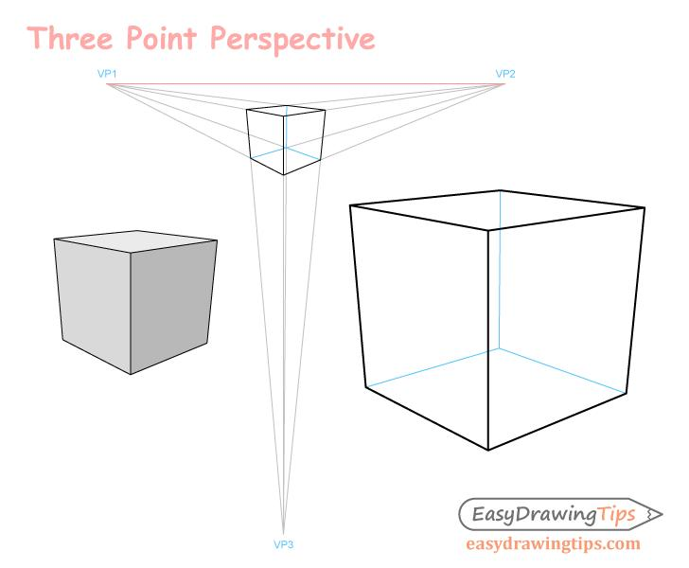
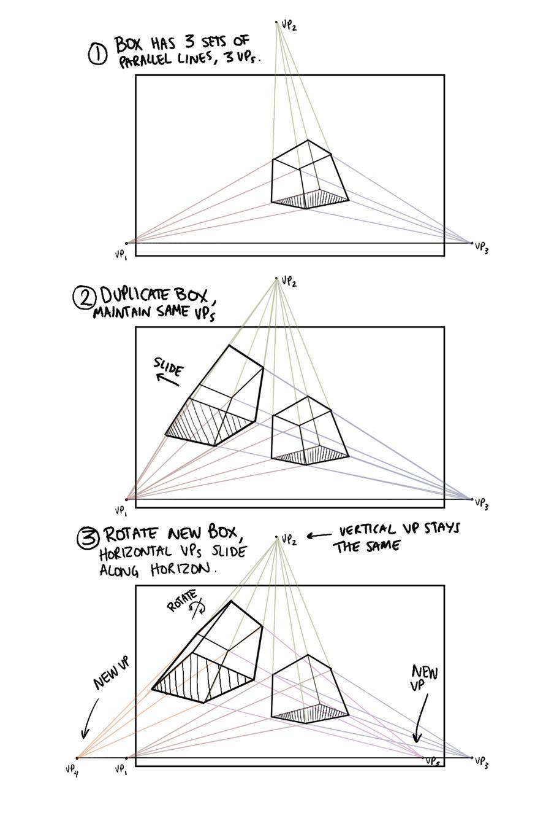
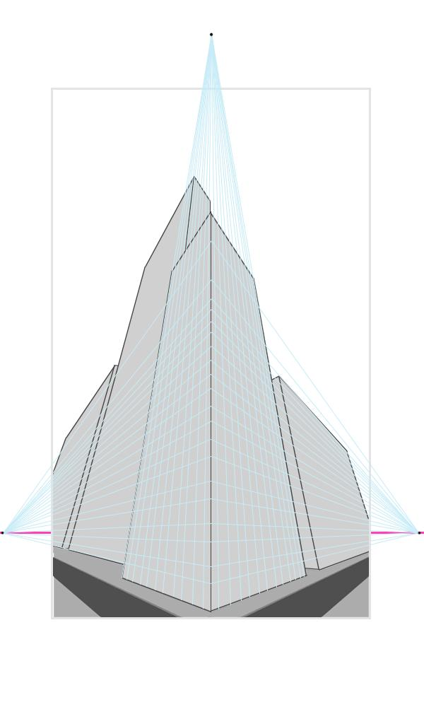
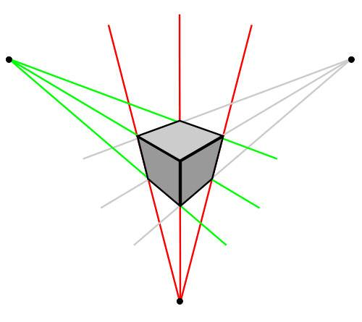
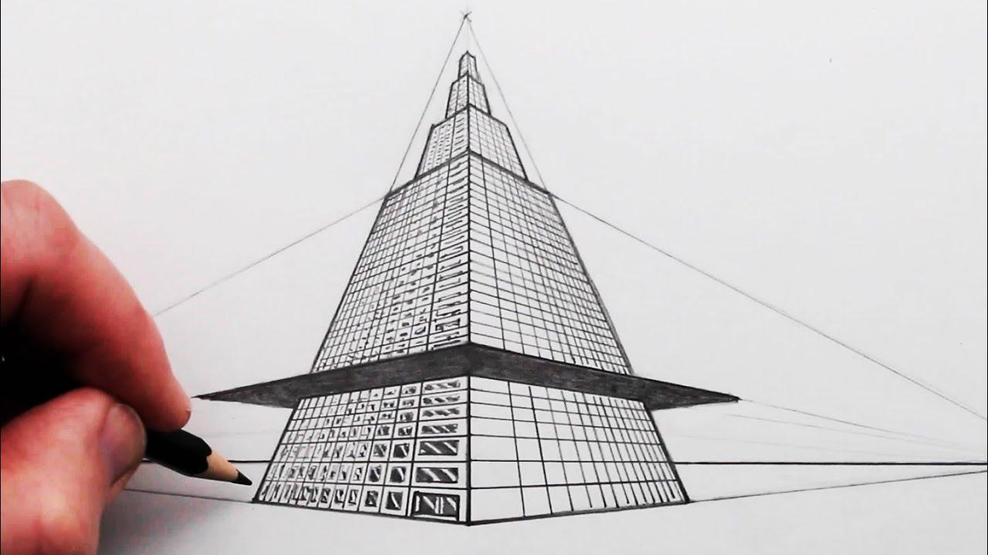

Properties
# Source: AI Source: Provided by: [Data Path: Persons Table -> ID Column: 1, Name_En Column: Motasem Essam] -> From: [ChatGPT] on [7/25/2026]
1. Three Principal Vanishing Points
The defining property is:
$$\boxed{N=3}$$
where $N$is the number of principal vanishing points.

2. Two Vanishing Points Are on the Horizon
$$\boxed{V_{L},V_{R}∈HL}$$

3. The Third Vanishing Point Represents Vertical Convergence
$$\boxed{V_{V}}$$
represents the convergence of the third principal direction.

4. Vertical Lines Can Converge
Unlike standard two-point perspective:
$$\boxed{\text{Vertical lines are not necessarily parallel}}$$
They converge toward:
$$V_{V}$$

5. Distant Parts Appear Smaller
As distance from the viewer increases:
$$\boxed{\text{Apparent size decreases}}$$

6. Strong Foreshortening
Three-point perspective can create strong foreshortening because the viewer is often looking significantly upward or downward.

7. Parallelism Is Not Generally Preserved
Parallel lines in 3D can appear to converge in the projected image.

Three-Point Perspective vs Two-Point Perspective
# Source: AI Source: Provided by: [Data Path: Persons Table -> ID Column: 1, Name_En Column: Motasem Essam] -> From: [ChatGPT] on [7/25/2026]
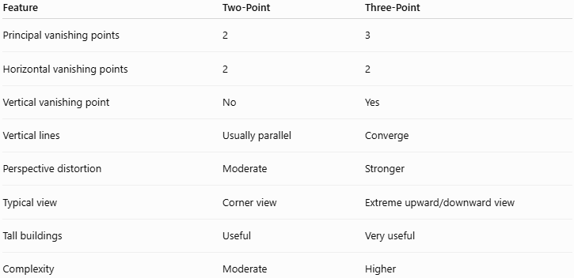
Feature | Two-Point | Three-Point
Principal vanishing points | 2 | 3
Horizontal vanishing points | 2 | 2
Vertical vanishing point | No | Yes
Vertical lines | Usually parallel | Converge
Perspective distortion | Moderate | Stronger
Typical view | Corner view | Extreme upward/downward view
Tall buildings | Useful | Very useful
Complexity | Moderate | Higher
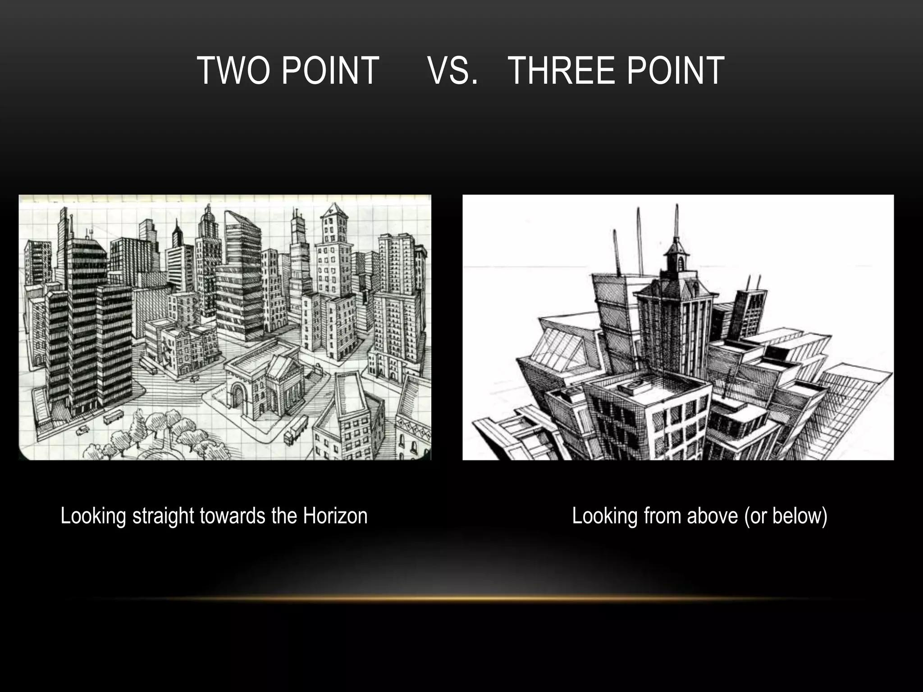
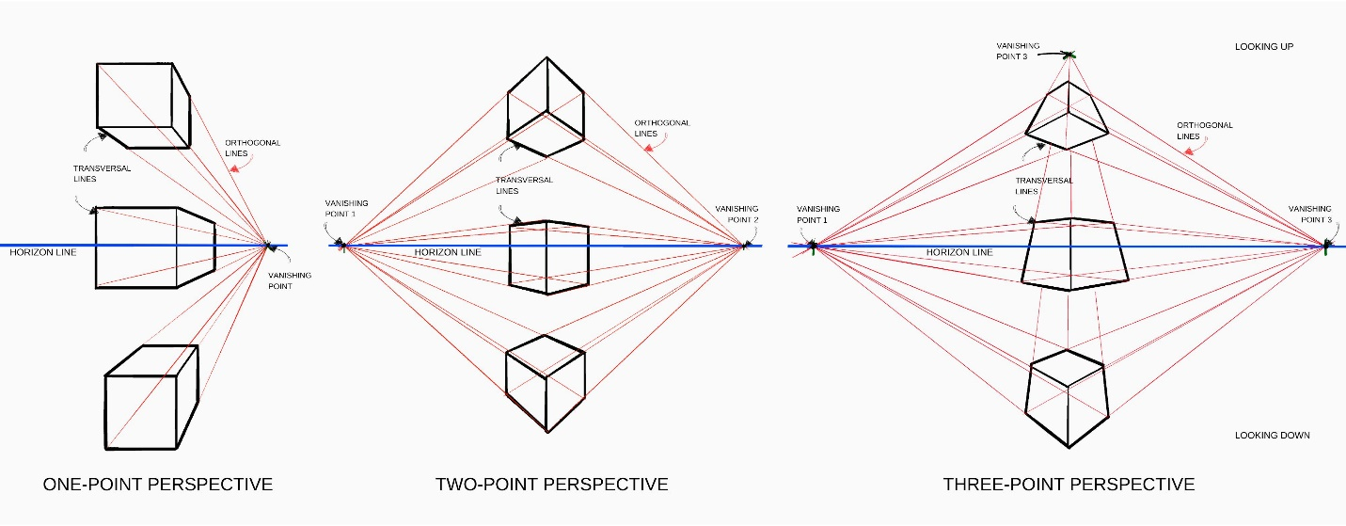
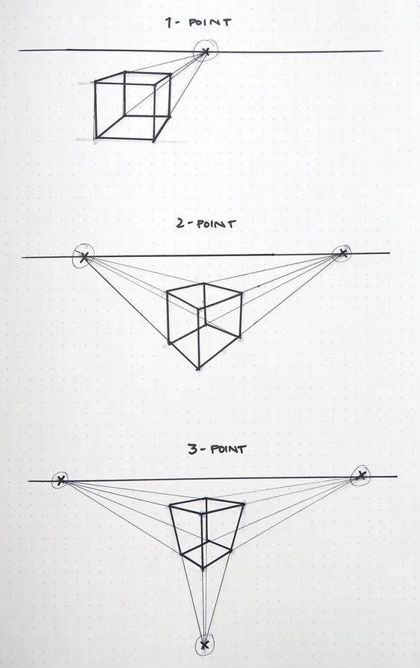
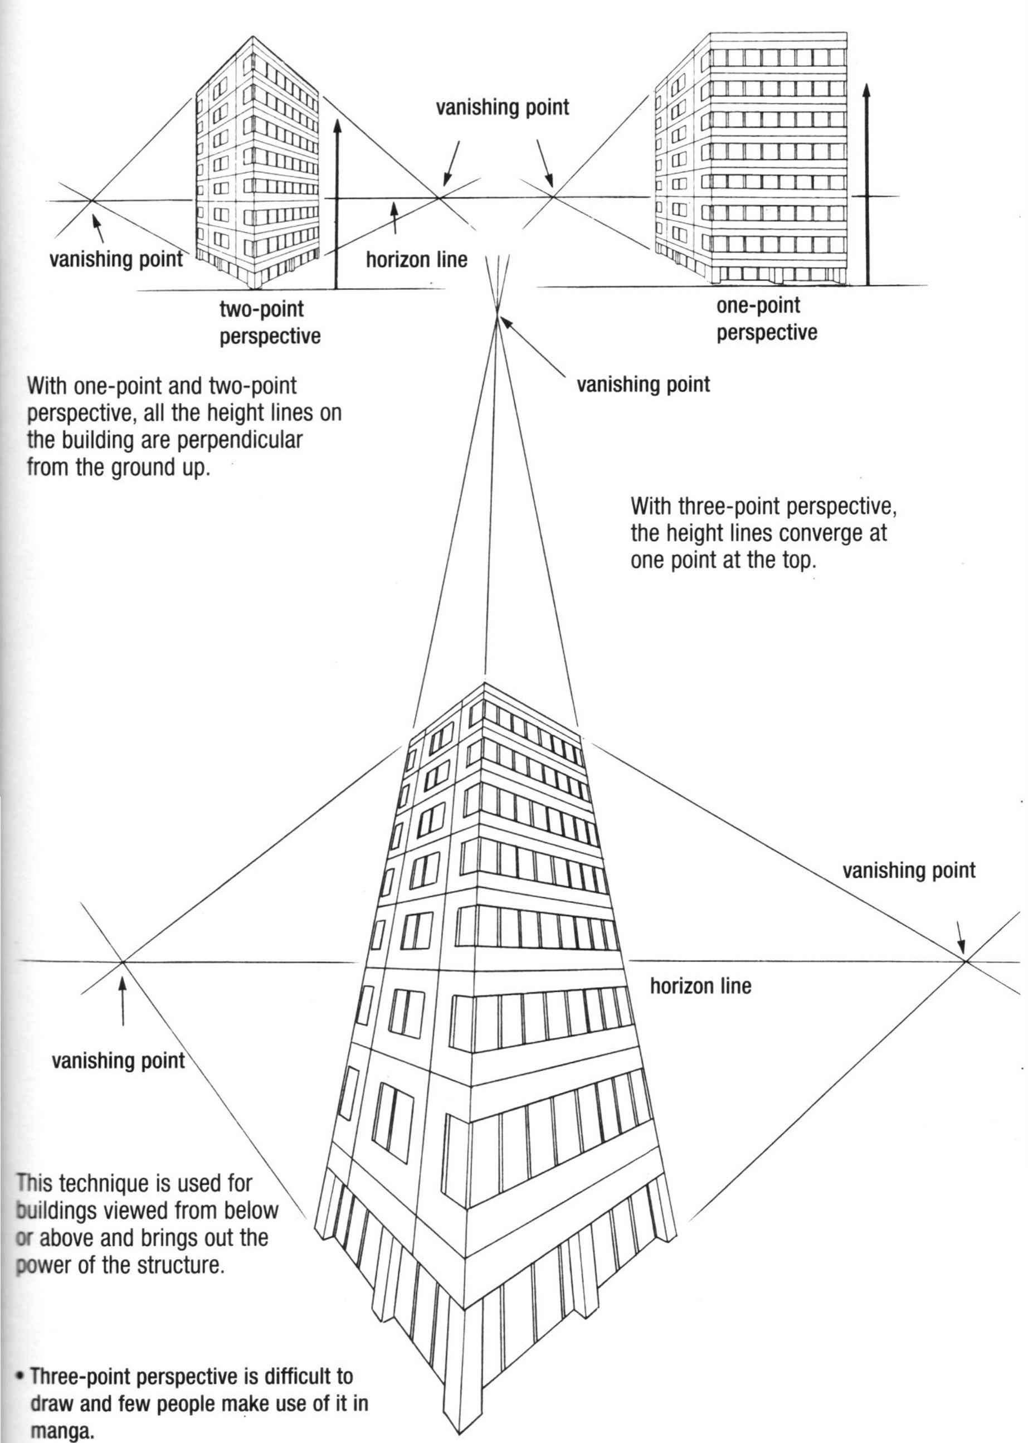
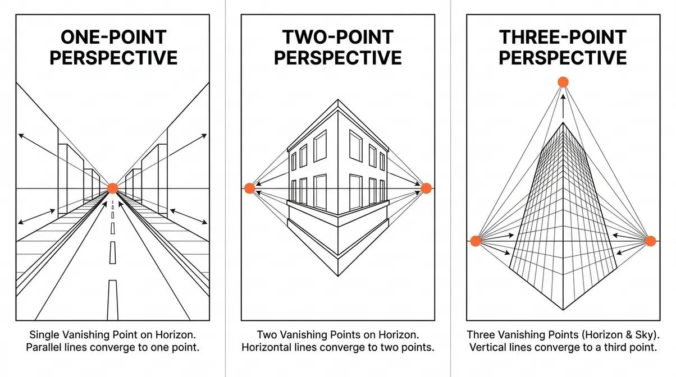

Three-Point Perspective vs One-Point Perspective
# Source: AI Source: Provided by: [Data Path: Persons Table -> ID Column: 1, Name_En Column: Motasem Essam] -> From: [ChatGPT] on [7/25/2026]
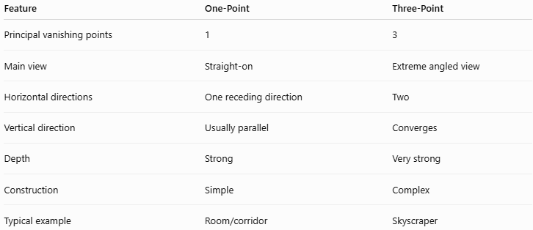
Feature | One-Point | Three-Point
Principal vanishing points | 1 | 3
Main view | Straight-on | Extreme angled view
Horizontal directions | One receding direction | Two
Vertical direction | Usually parallel | Converges
Depth | Strong | Very strong
Construction | Simple | Complex
Typical example | Room/corridor | Skyscraper

Three-Point Perspective vs Parallel Projection
# Source: AI Source: Provided by: [Data Path: Persons Table -> ID Column: 1, Name_En Column: Motasem Essam] -> From: [ChatGPT] on [7/25/2026]
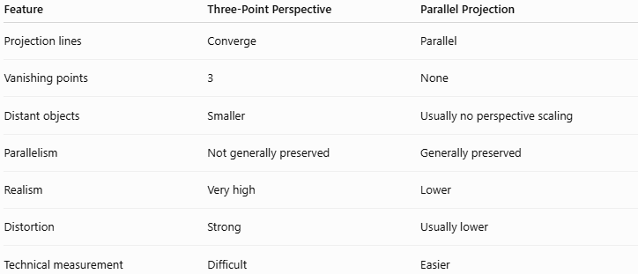
Feature | Three-Point Perspective | Parallel Projection
Projection lines | Converge | Parallel
Vanishing points | 3 | None
Distant objects | Smaller | Usually no perspective scaling
Parallelism | Not generally preserved | Generally preserved
Realism | Very high | Lower
Distortion | Strong | Usually lower
Technical measurement | Difficult | Easier

Three-Point Perspective vs Cavalier Projection
# Source: AI Source: Provided by: [Data Path: Persons Table -> ID Column: 1, Name_En Column: Motasem Essam] -> From: [ChatGPT] on [7/25/2026]
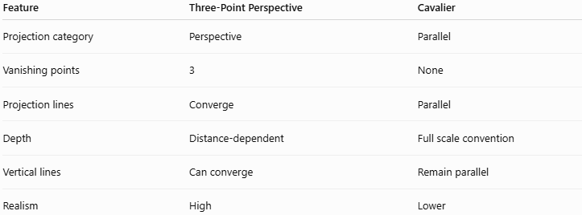
Feature | Three-Point Perspective | Cavalier
Projection category | Perspective | Parallel
Vanishing points | 3 | None
Projection lines | Converge | Parallel
Depth | Distance-dependent | Full scale convention
Vertical lines | Can converge | Remain parallel
Realism | High | Lower

Three-Point Perspective vs Cabinet Projection
# Source: AI Source: Provided by: [Data Path: Persons Table -> ID Column: 1, Name_En Column: Motasem Essam] -> From: [ChatGPT] on [7/25/2026]
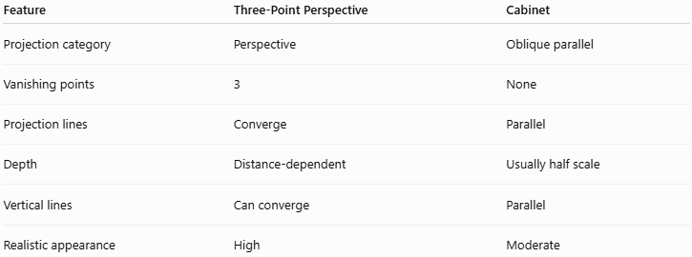
Feature | Three-Point Perspective | Cabinet
Projection category | Perspective | Oblique parallel
Vanishing points | 3 | None
Projection lines | Converge | Parallel
Depth | Distance-dependent | Usually half scale
Vertical lines | Can converge | Parallel
Realistic appearance | High | Moderate

Applications
# Source: AI Source: Provided by: [Data Path: Persons Table -> ID Column: 1, Name_En Column: Motasem Essam] -> From: [ChatGPT] on [7/25/2026]
Three-point perspective is commonly used in:
- Architecture
- Skyscraper visualization
- Architectural photography
- Urban visualization
- Film
- Animation
- Video games
- Concept art
- Computer graphics
- Virtual reality
- 3D modeling
- Cinematic compositions
- Dramatic illustrations

Advantages
# Source: AI Source: Provided by: [Data Path: Persons Table -> ID Column: 1, Name_En Column: Motasem Essam] -> From: [ChatGPT] on [7/25/2026]
- Creates a very strong sense of depth.
- Produces highly realistic images.
- Suitable for tall structures.
- Represents extreme camera angles.
- Allows both upward and downward views.
- Useful for dramatic architectural scenes.
- Closely approximates photographic perspective.

Limitations
# Source: AI Source: Provided by: [Data Path: Persons Table -> ID Column: 1, Name_En Column: Motasem Essam] -> From: [ChatGPT] on [7/25/2026]
- More complicated than one-point and two-point perspective.
- Can create strong distortion.
- True dimensions are not directly preserved.
- Requires three vanishing points.
- Vertical lines can become heavily angled.
- Can make objects appear unnaturally distorted if the viewpoint is extreme.
- Less suitable for precise technical measurements.

Special Cases

Looking Up
# Source: AI Source: Provided by: [Data Path: Persons Table -> ID Column: 1, Name_En Column: Motasem Essam] -> From: [ChatGPT] on [7/25/2026]
When viewing a tall object from below:
$$\boxed{V_{V}\text{ is above the horizon line}}$$
The vertical edges converge upward.

Looking Down
# Source: AI Source: Provided by: [Data Path: Persons Table -> ID Column: 1, Name_En Column: Motasem Essam] -> From: [ChatGPT] on [7/25/2026]
When viewing a tall object from above:
$$\boxed{V_{V}\text{ is below the horizon line}}$$
The vertical edges converge downward.

Vertical Vanishing Point at Infinity
# Source: AI Source: Provided by: [Data Path: Persons Table -> ID Column: 1, Name_En Column: Motasem Essam] -> From: [ChatGPT] on [7/25/2026]
If the vertical direction becomes parallel to the picture plane, its vanishing point moves effectively to infinity.
The vertical lines then become parallel.
This approaches the standard two-point perspective configuration.
Conceptually:
$$\boxed{V_{V}→∞ ⇒ \text{Two-Point Perspective}}$$

Relationship to Perspective Projection
# Source: AI Source: Provided by: [Data Path: Persons Table -> ID Column: 1, Name_En Column: Motasem Essam] -> From: [ChatGPT] on [7/25/2026]
The hierarchy is:
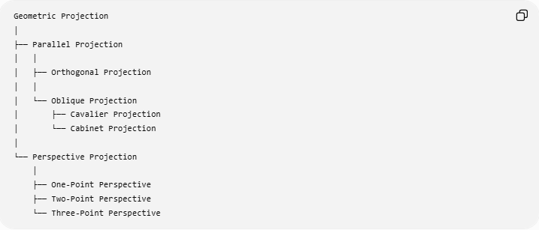
Geometric Projection
│
├── Parallel Projection
│ │
│ ├── Orthogonal Projection
│ │
│ └── Oblique Projection
│ ├── Cavalier Projection
│ └── Cabinet Projection
│
└── Perspective Projection
│
├── One-Point Perspective
├── Two-Point Perspective
└── Three-Point Perspective
Therefore:
$$\boxed{\text{Three-Point Perspective}⊂\text{Perspective Projection}}$$

Key Points
# Source: AI Source: Provided by: [Data Path: Persons Table -> ID Column: 1, Name_En Column: Motasem Essam] -> From: [ChatGPT] on [7/25/2026]
- Three-Point Perspective is a type of perspective projection.
- It uses three principal vanishing points.
- Two vanishing points represent the two principal horizontal directions:
$$V_{L}, V_{R}$$
- The third represents the vertical direction:
$$V_{V}$$
- The two horizontal vanishing points lie on the horizon line:
$$\boxed{V_{L},V_{R}∈HL}$$
- The vertical vanishing point is generally above or below the horizon.
- Vertical lines can converge.
- It is especially useful for tall buildings and extreme upward/downward views.
- It produces stronger perspective distortion than one-point and two-point perspective.

Conclusion
# Source: AI Source: Provided by: [Data Path: Persons Table -> ID Column: 1, Name_En Column: Motasem Essam] -> From: [ChatGPT] on [7/25/2026]
Three-Point Perspective is the most general of the three common perspective systems for representing rectangular 3D objects. It uses two horizontal vanishing points and a third vertical vanishing point, allowing horizontal and vertical directions to converge.
$$\boxed{\text{Three-Point Perspective}=\text{Two Horizontal Vanishing Points}+\text{One Vertical Vanishing Point}}$$
The key progression is:
$$\boxed{\text{One-Point}→\text{Two-Point}→\text{Three-Point}}$$
as additional spatial directions are allowed to converge.

